**CONTROL STRUCTURES**

**SCENERIO 1:**

The bank wants to apply a discount to loan interest rates for customers above 60 years old.

**Step 1: Create the customers table**

CREATE TABLE customers (

    customer_id   NUMBER PRIMARY KEY,

    customer_name VARCHAR2(100),

    age           NUMBER,

    loan_interest NUMBER

);

**OUTPUT:**

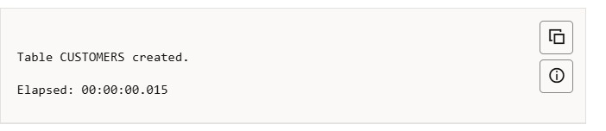

**Step 2: Insert sample records**

INSERT INTO customers VALUES (1, 'Nigashini', 65, 9.0);

INSERT INTO customers VALUES (2, 'Dharshana', 55, 10.0);

COMMIT;

**OUTPUT:**

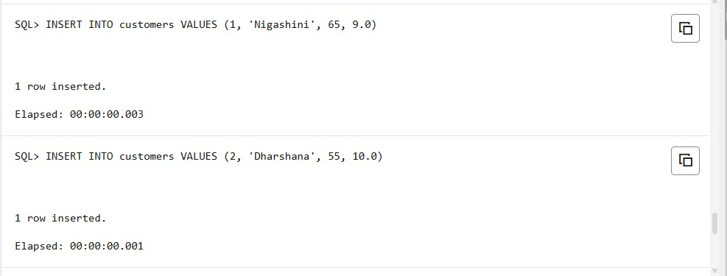

**Step 3: Apply 1% discount using PL/SQL block**

BEGIN

FOR cust IN (SELECT customer_id, age FROM customers) LOOP

IF cust.age > 60 THEN

UPDATE customers

SET loan_interest = loan_interest - 1

WHERE customer_id = cust.customer_id;

END IF;

END LOOP;

COMMIT;

END;

/

**OUTPUT:**

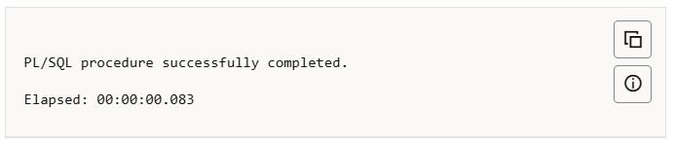

**Step 5: View the updated results**

SELECT * FROM customers;

**OUTPUT:**

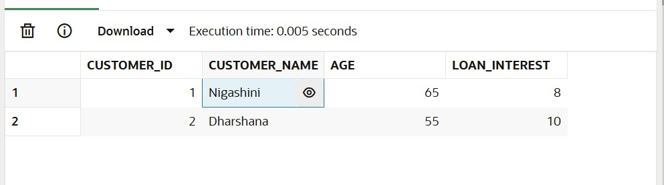

**SCENARIO 2:**

A customer can be promoted to VIP status based on their balance.

CREATE TABLE Customer_1 (

CustomerID NUMBER PRIMARY KEY,

Name VARCHAR2(100),

DOB DATE,

Balance NUMBER,

LastModified DATE,

IsVIP VARCHAR2(5)

);

**Step 1: Insert Sample Data**

INSERT INTO Customer_1 (CustomerID, Name, DOB, Balance, LastModified)

VALUES (1, 'Nivetha', TO_DATE('1985-05-15', 'YYYY-MM-DD'), 8000, SYSDATE);

INSERT INTO Customers_1(CustomerID, Name, DOB, Balance, LastModified)

VALUES (2, 'Sibi', TO_DATE('1990-07-20', 'YYYY-MM-DD'), 12000, SYSDATE);

INSERT INTO Customer_1 (CustomerID, Name, DOB, Balance, LastModified)

VALUES (3, 'Vidhya', TO_DATE('1970-01-10', 'YYYY-MM-DD'), 20000, SYSDATE);

**Step 2: PL/SQL Block to Set IsVIP Flag**

BEGIN

FOR cust IN (SELECT CustomerID, Balance FROM Customers) LOOP

IF cust.Balance > 10000 THEN

UPDATE Customer_1

SET IsVIP = 'TRUE',

LastModified = SYSDATE

WHERE CustomerID = cust.CustomerID;

ELSE

UPDATE Customers

SET IsVIP = 'FALSE',

LastModified = SYSDATE

WHERE CustomerID = cust.CustomerID;

END IF;

END LOOP;

END;

/

**Step 3: Check Results**

SELECT * FROM Customer_1;

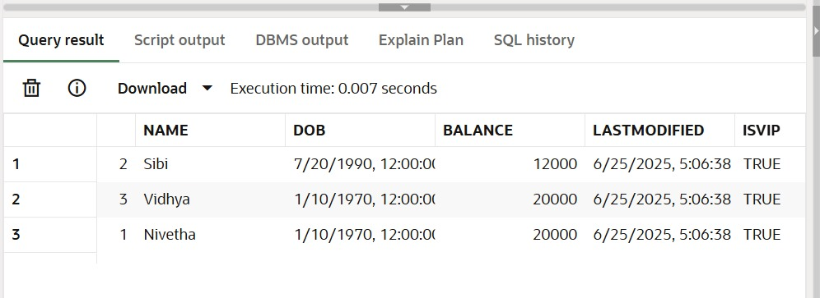

**SCENARIO 3:**

The bank wants to send reminders to customers whose loans are due within the next 30 days.

CREATE TABLE Loans (

LoanID NUMBER PRIMARY KEY,

CustomerID NUMBER,

LoanAmount NUMBER,

InterestRate NUMBER,

StartDate DATE,

EndDate DATE,

FOREIGN KEY (CustomerID) REFERENCES Customers(CustomerID)

);

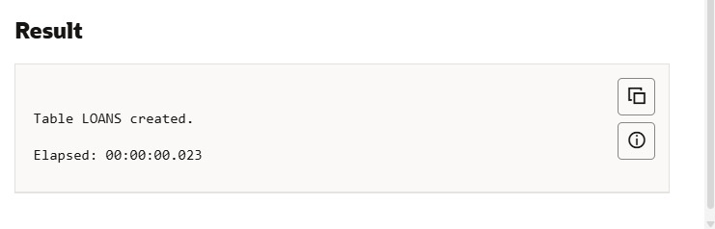 **Insert Sample Data**

INSERT INTO Loans (LoanID, CustomerID, LoanAmount, InterestRate, StartDate, EndDate)

VALUES (1, 1, 10000, 5, SYSDATE - 300, SYSDATE + 10);

INSERT INTO Loans (LoanID, CustomerID, LoanAmount, InterestRate, StartDate, EndDate)

VALUES (1, 1, 50000, 5, SYSDATE - 200, SYSDATE + 10);

INSERT INTO Loans (LoanID, CustomerID, LoanAmount, InterestRate, StartDate, EndDate)

VALUES (1, 1, 45000, 5, SYSDATE - 300, SYSDATE + 10);

**PL/SQL Block to Print Loan Reminders**

BEGIN

FOR loan_rec IN (

SELECT LoanID, CustomerID, LoanAmount, EndDate

FROM Loans

WHERE EndDate <= SYSDATE + 30

) LOOP

DBMS_OUTPUT.PUT_LINE('Reminder: Loan ID ' || loan_rec.LoanID ||

' for Customer ID ' || loan_rec.CustomerID ||

' of amount ₹' || loan_rec.LoanAmount ||

' is due on ' || TO_CHAR(loan_rec.EndDate, 'DD-MON-YYYY'));

END LOOP;

END;/

SET SERVEROUTPUT ON;

SELECT * FROM Loans

WHERE EndDate <= SYSDATE + 30;

**OUTPUT:**

